|  |  |
| --- | --- |
| Stella Nova Logo | LOGO4 |
| Best Buy Canada Mobile | |
| |  | | --- | | **Reprint Receipt Feature Document** |   **Document Version: 1.0**  **Design Date: October 28, 2013** | |
| **Prepared By: Amy Lackas** | |

**Table of Contents**

*1.* *Feature Overview* 3

1.1 Feature Description 3

1.2 Assumptions 3

1.3 Parameters and System Settings 3

1.4 Interfaces 3

*2.* *USE CASE: Reprint Last Tran Receipt* 3

2.1 Feature Flow 3

2.2 Precondition 4

2.3 Main Flow 4

2.4 Alternate Flows 4

2.5 Post Condition 4

2.6 Special Requirements 4

*3.* *USE CASE: Reprint Last Tran Gift Receipt* 5

3.1 Feature Flow 5

3.2 Precondition 5

3.3 Main Flow 5

3.4 Alternate Flows 5

3.5 Post Condition 5

3.6 Special Requirements 5

*4.* *USE CASE: Reprint Receipt* 6

4.1 Feature Flow 6

4.2 Precondition 6

4.3 Main Flow 6

4.4 Alternate Flows 7

4.5 Post Condition 7

4.6 Special Requirements 7

*5.* *Supplemental Specifications* 8

5.1 Electronic Journal 8

5.2 Modify Transaction 8

5.3 POSLog 8

5.4 Printed Receipts 8

5.5 Transaction Search 8

*6.* *Screen Layouts* 9

6.1 Enter Gift Receipt Quantity 9

6.2 Transaction List – Reprint Receipt 10

*7.* *Business Sign Off* 11

*8.* *Revision History* 11

*9.* *Appendix A: Glossary* 12

# *Feature Overview*

## Feature Description

During the printing of a receipt the printer may run out of paper or there is a communication issue that prevents the receipt to be printed or the operator/customer would like a copy of the receipt. The reprint last transaction receipt or print gift receipt for last transaction on a device is an option for the operator to go to a different printer or correct the issue on the printer and try again. When the Reprint Receipt option is selected, the system regenerates the receipt or gift receipt for the last transaction completed on the device.

## Assumptions

1. All text displayed by the system is configurable by brand to support multi-language.  Text is defined from an external source or defined within the system.
2. All Manager Overrides are bypassed.

## Parameters and System Settings

|  |  |  |
| --- | --- | --- |
| **Parameter Mnemonic** | **Description** | **Valid Values** |
| None |  |  |

## Interfaces

|  |  |
| --- | --- |
| **Interface** | **Description** |
| Transaction Lookup Service | Searches for transactions against the Customer’s database. The search criteria can be 4-part transaction key, tender or customer details. |
| Corporate Receipt Lookup Service | Searches for receipt text against the Customer’s database. The search criteria are the 4-part transaction key. |

# *USE CASE: Reprint Last Tran Receipt*

## Feature Flow

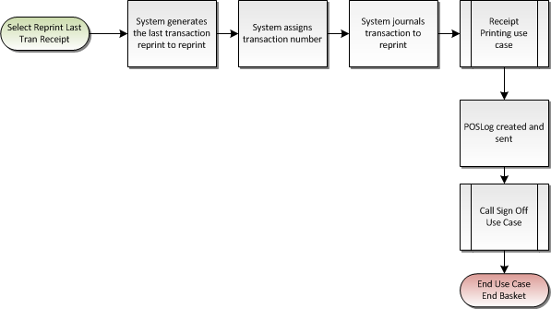

Figure 1: Reprint Receipt Main Flow

## Precondition

* The operator has selected to reprint the receipt for the last transaction.

## Main Flow

1. The system generates the last transaction receipt details from the device.
2. The system assigns and logs a transaction number to the reprint receipt transaction.
3. The system collects the last transaction receipt details for the device.
4. The system journals the transaction information for the receipt to be reprinted.
5. The system logs the transaction was reprinted.
6. The system executes Receipt Printing Use Case with the last transaction receipt details.
7. The system returns from Printing Use Case.
8. The system creates and sends the POSLog.
9. The use case ends and the system executes the Sign Off Use Case.

## Alternate Flows

None

## Post Condition

* Receipt is reprinted.

## Special Requirements

1. The printed receipt contains a configurable heading ‘Duplicate Receipt’ above the transaction header text to print for all receipt reprints except for reprinting a gift receipt.

### Special Offline Requirements

TBD

### Data Input/Output

|  |  |  |
| --- | --- | --- |
| **Data Element** | **Description** | **Destination** |
| Transaction Key | The four-part transaction key of the receipt to be reprinted. | * E-Journal * POSLog |
| Receipt Data | The collected receipt data to reprint. | * Printing Use Case |

# *USE CASE: Reprint Last Tran Gift Receipt*

## Feature Flow

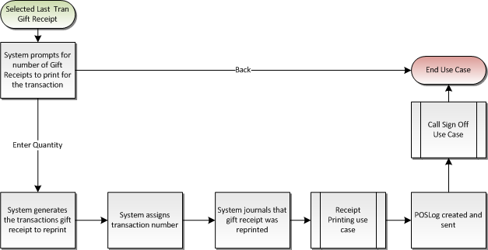

Figure 2: Reprint Last Tran Gift Receipt Main Flow

## Precondition

* The operator has selected to reprint a gift receipt for the last transaction

## Main Flow

1. The system prompts the operator to enter the quantity of gift receipts.
2. The operator enters in an amount and accepts the entry.
3. The system assigns and logs a transaction number to the reprint receipt transaction.
4. The system generates the gift receipt for last transaction receipt details for the device.
5. The system journals the transaction information for the receipt to be reprinted.
6. The system logs the transaction was reprinted.
7. The system executes Receipt Printing Use Case with the last transaction gift receipt details and the quantity to reprint.
8. The system returns from Printing Use Case.
9. The system creates and sends the POSLog.
10. The use case ends and the system executes the Sign Off Use Case.

## Alternate Flows

None

## Post Condition

* Gift receipts are printed.

## Special Requirements

1. The printed receipt contains a configurable heading ‘Duplicate Receipt’ above the transaction header text to print for all receipt reprints except for reprinting a gift receipt.
2. The reprint last transaction gift receipt option prints a transaction receipt, there is no option to create item level gift receipts.
3. The option to print a gift receipt for the last transaction is available for all eligible transaction types (Sale) even if the original transaction did not print a gift receipt. The system generates a transaction gift receipt.
4. The system only prints up to the maximum number of items in the transaction.
5. Layaway Deposit and Pre-Order Deposit transaction types are not eligible to reprint gift receipt.

### Special Offline Requirements

TBD

### Data Input/Output

|  |  |  |
| --- | --- | --- |
| **Data Element** | **Description** | **Destination** |
| Transaction Key | The four-part transaction key of the receipt to be reprinted. | * E-Journal * POSLog |
| Receipt Data | The collected receipt data to reprint. | * Printing Use Case |

# *USE CASE: Reprint Receipt*

## Feature Flow

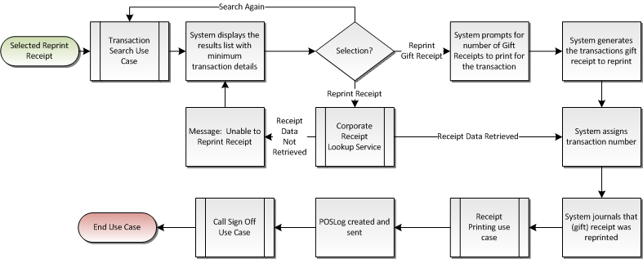

## Precondition

* The operator has selected to reprint a receipt

## Main Flow

1. The system executes the Transaction Search-Search by Tender use case.
2. The system returns from the Transaction Search use case with transaction(s) details.
3. The system displays the list of transaction from the search along with details of the transaction.
4. If the user selects to search again, the system restarts the Main Flow executing the Transaction Search use case.
5. If the user selects a transaction to reprint a gift receipt, the Reprint Gift Receipt alternate flow is executed.
6. If the user selects a transaction to reprint the receipt, the system calls Corporate Receipt Lookup Service to retrieve the receipt data for the selected transaction.
7. If the service returns without the receipt data, the system displays a message, the operator acknowledges the message, the system returns to the Main Flow where the system displays the list of transactions.
8. The system generates the receipt data from the response.
9. The system assigns and logs a transaction number to the reprint receipt transaction.
10. The system collects the last transaction receipt details for the device.
11. The system journals the transaction information for the receipt to be reprinted.
12. The system logs the transaction was reprinted.
13. The system executes Receipt Printing Use Case with the last transaction receipt details.
14. The system returns from Printing Use Case.
15. The system creates and sends the POSLog.
16. The use case ends and the system executes the Sign Off Use Case.

## Alternate Flows

### Reprint Gift Receipt

1. The system prompts the operator to enter the quantity of gift receipts.
2. The operator enters in an amount and accepts the entry.
3. The system returns to the Main Flow where the system assigns and logs a transaction number.

## Post Condition

* Receipt is printed.

## Special Requirements

1. The system displays the Transaction Search by Tender screen initially with the options to go to the other transaction search options.
2. Receipt data for Reprint Receipt is from the E-Journal text that is written to the Corporate Receipt Lookup database. The system does not generate the receipt, but will use the data in the Corporate Receipt Lookup Service response. The clean receipt data is used.
3. Receipt data for Reprint Gift Receipt is rebuilt from the data returned in Transaction Lookup Service response.
4. The printed receipt contains a configurable heading ‘Duplicate Receipt’ above the transaction header text to print for all receipt reprints except for reprinting a gift receipt.
5. The reprint last transaction gift receipt option prints a transaction receipt, there is no option to create item level gift receipts.
6. The option to print a gift receipt for the last transaction is available for all eligible transaction types (Sale) even if the original transaction did not print a gift receipt. The system generates a transaction gift receipt.
7. The system only prints up to the maximum number of items in the transaction.

### Special Offline Requirements

TBD

### Data Input/Output

|  |  |  |
| --- | --- | --- |
| **Data Element** | **Description** | **Destination** |
| Transaction Key | The four-part transaction key of the receipt to be reprinted. | * E-Journal * POSLog |
| Receipt Data | The collected receipt data to reprint. | * Printing Use Case |

# *Supplemental Specifications*

## Electronic Journal

Electronic journal mockups for this feature are documented in the Electronic Journal document.

## Modify Transaction

The Modify Transaction use case is updated to add the Reprint Receipt, Reprint Gift Receipt, Reprint Last Tran Gift Receipt and Reprint Last Tran Receipt menu option.

The Modify Transaction use case is updated to check if manager override is required to continue if the Reprint Receipt, Reprint Gift Receipt, Reprint Last Transaction Gift Receipt or the Reprint Last Transaction option is selected from the Transaction Modify menu.

## POSLog

POSLog mockups for this feature are documented in the POSLog document.

## Printed Receipts

Printed receipt mockups, where applicable, are documented in the Receipt document.

## Transaction Search

The Transaction Search use case is called when the Reprint Receipt or Reprint Gift Receipt transaction is executed.

# *Screen Layouts*

## Enter Gift Receipt Quantity

This pop over is displayed when the Reprint Last Transaction Gift Receipt is selected and prompts the operator to enter the number of gift receipts to print.

### Mockup

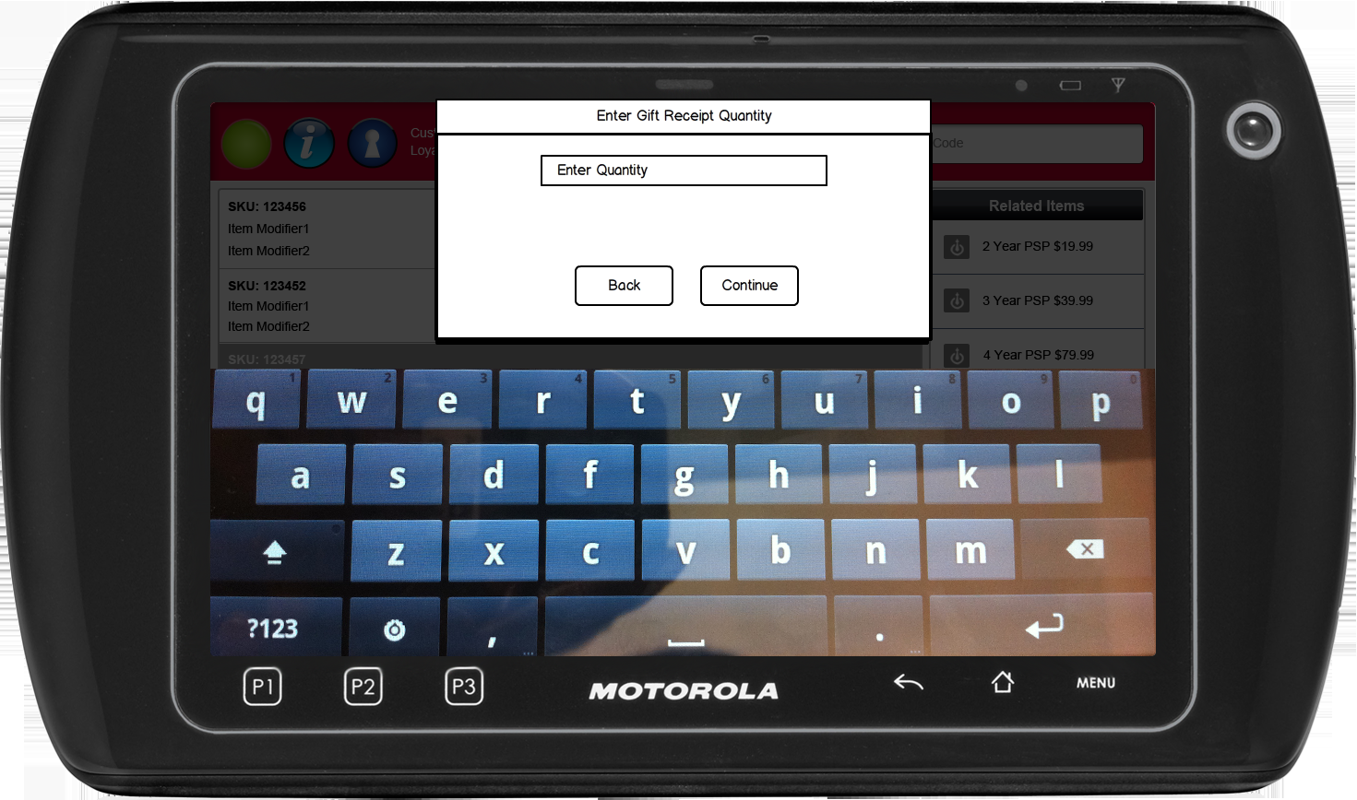

Figure 3: Enter Gift Receipt Quantity

### Instruction Text Enhancements

|  |
| --- |
| **Instructions** |
| None |

### Navigation/Menu Key Enhancements

|  |  |  |  |
| --- | --- | --- | --- |
| **Label** | **State** | **Next Screen** | **Notes** |
| Back | Enabled | Sale use case | None |
| Continue | See Notes | Receipt Printing use case | Continue enabled upon data entry |

### Data/Input Field Enhancements

|  |  |  |  |  |  |  |
| --- | --- | --- | --- | --- | --- | --- |
| **Label** | **Editable** | **Req’d?** | **Data Type** | **Min**  **Length** | **Max**  **Length** | **Notes** |
| Enter Quantity | Yes | Yes | Numeric | 1 | 10 | None |

### Reason Code Enhancements

|  |  |  |
| --- | --- | --- |
| **Reason Code** | **Valid Values** | **Default Value** |
| None |  |  |

### Invalid Gift Receipt Quantity

|  |  |
| --- | --- |
| **Description** | The Invalid Gift Receipt Quantity message is displayed when the gift receipt quantity number entered is greater than the number of items in the transaction. Acknowledging the message returns the operator to the Enter Gift Receipt Quantity. |
| **Message** | Invalid Gift Receipt Quantity |
| **Key prompt** | OK |
| **Notes** | Configurable message |

## Transaction List – Reprint Receipt

This screen is displayed when the operator selects to search for a transaction. The screen displays the transaction information consisting of the date of purchase, store number, device ID, transaction number~~,~~ and total for the transaction. The operator has the option to select a transaction to Reprint Receipt or Reprint Gift Receipt. The first transaction is highlighted by default. Transactions are listed in chronological order starting with the newest transaction listed first.

The system displays only transactions within the same brand as current store.

### Mockup

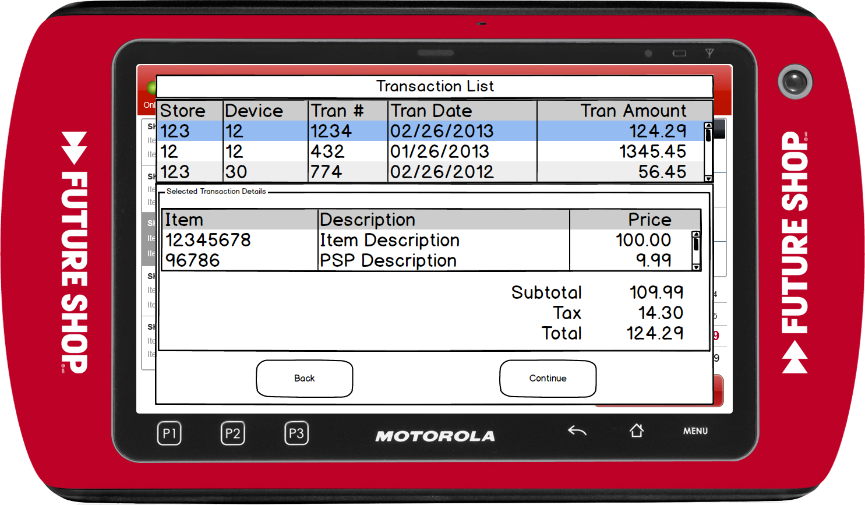

Figure 4: Transaction List

### Instruction Text

|  |
| --- |
| **Instructions** |
| None |

### Navigation/Menu Key

|  |  |  |  |
| --- | --- | --- | --- |
| **Label Text** | **State** | **Next Screen** | **Notes** |
| Back | Enabled | Previous screen | None |
| Continue | Enabled | * Reprint Receipt selected from Main Menu and Receipt details returned from Corporate Receipt Lookup Service: Reprint Receipt use case * Reprint Receipt selected from Main Menu and Receipt details not returned from Corporate Receipt Lookup Service: Unable to Reprint Receipt * Reprint Gift Receipt selected from Main Menu: Reprint Receipt use Case | None |

### Data/Input Field

|  |  |  |  |  |  |  |
| --- | --- | --- | --- | --- | --- | --- |
| **Label/Placeholder Text** | **Editable** | **Req’d?** | **Data Type** | **Min**  **Length** | **Max**  **Length** | **Notes** |
| Store # | No | N/A | Numeric | N/A | N/A | Display Only |
| Device# | No | N/A | Numeric | N/A | N/A | Display Only |
| Tran # | No | N/A | Numeric | N/A | N/A | Display Only |
| Date | No | N/A | Date | N/A | N/A | Display Only |
| Total | No | N/A | Currency | N/A | N/A | Display Only |
| Item | No | N/A | Numeric | N/A | N/A | Display Only |
| Item Description | No | N/A | Alphanumeric | N/A | N/A | Display Only |
| Price | No | N/A | Currency | N/A | N/A | Display Only |
| Subtotal | No | N/A | Currency | N/A | N/A | Display Only |
| Tax | No | N/A | Currency | N/A | N/A | Display Only |
| Total | No | N/A | Currency | N/A | N/A | Display Only |

### Reason Code

|  |  |  |
| --- | --- | --- |
| **Reason Code** | **Valid Values** | **Default Value** |
| None |  |  |

### Unable to Reprint Receipt

|  |  |
| --- | --- |
| **Description** | The Unable to Reprint Receipt message is displayed when no receipt information is returned from the Corporate Receipt Lookup Service. Acknowledging the message returns the operator to the Transaction List screen. |
| **Message** | Unable to Reprint Receipt |
| **Key prompt** | OK |
| **Notes** | Configurable message |

# *Business Sign Off*

|  |  |  |
| --- | --- | --- |
| **Name** | **Organization** | **Date** |
| <Name of signer> | <Organization of signer if applicable> | <date of sign off> |

# *Revision History*

|  |  |  |  |
| --- | --- | --- | --- |
| **Reviser** | **Revision** | **Date** | **Version** |
| Amy Lackas | Initial document created. Updated with new features: Layaway Deposit, Pre-Order Deposit | 10/28/2013 | 1.0 |
| Amy Byers | Added Requirements Matrix | 9/10/2014 | 1.1 |

# *Appendix : Source Documentation*

* Requirement Specification - XPOS

## Functional Requirements

| **ID** | **Category** | **Sub-Category** | **Description** | **Section(s)** |
| --- | --- | --- | --- | --- |
| 2.24 | Functions | Reprint Receipt | A user will not be required to obtain a manager approval if they choose to only reprint a gift receipt (last gift receipt or searched gift receipt). | * 4.4.1 Reprint Gift Receipt |

# *Appendix : Glossary*

|  |  |
| --- | --- |
| **Term** | **Definition** |
|  |  |